IMPLEMENTATION OF LIST , LINEAR , BINARY SEARCH USING ADT

NAME : FEBINE M E
ROLL NO : 25BAD024

Pseudocode for List ADT Operations (Array Implementation)
Algorithm
START
- Read the number of elements (size).
- Read the array elements.
- Display the original array.

Insert Operation
- Read the position and value to be inserted.
- Shift all elements from the last element up to the given position one place to the right.
- Insert the new value at the given position.
- Increase the size of the array by 1.
- Display the updated array.

Delete Operation
- Read the position of the element to be deleted.
- Shift all elements after the given position one place to the left.
- Decrease the size of the array by 1.
- Display the updated array.

Linear Search
- Read the search key.
- Compare the search key with each element in the array from left to right.
- If the element is found:
  - Display "Element Found" along with its position.
  - Stop the search.
- If the search reaches the end of the array without finding the element:
  - Display "Element Not Found".

Binary Search
Note: Binary Search works only on a sorted array.
- Read the search key.
- Set Low = 0 and High = Size − 1.
- Repeat while Low ≤ High:
  - Calculate Mid = (Low + High) / 2.
  - If the middle element is equal to the search key:
    - Display "Element Found" along with its position.
    - Stop the search.
  - Else if the search key is smaller than the middle element:
    - Set High = Mid − 1.
  - Else:
    - Set Low = Mid + 1.
- If the element is not found after the loop ends:
  - Display "Element Not Found".

STOP

Summary of Operations
Operation | Description
Insert | Adds a new element at the specified position by shifting existing elements to the right.
Delete | Removes an element from the specified position by shifting remaining elements to the left.
Display | Prints all elements currently present in the array.
Linear Search | Searches each element sequentially until the required element is found or the array ends.
Binary Search | Searches a sorted array by repeatedly dividing the search range into two halves.

CODE
#include <stdio.h>

// Display the array
void display(int arr[], int size)
{
for (int i = 0; i < size; i++)
{
printf("%d ", arr[i]);
}
printf("\n");
}

// Insert an element
void insert(int arr[], int *size, int pos, int value)
{
for (int i = *size; i > pos; i--)
{
arr[i] = arr[i - 1];
}

arr[pos] = value;
(*size)++;
}

// Delete an element
void deleteElement(int arr[], int *size, int pos)
{
for (int i = pos; i < *size - 1; i++)
{
arr[i] = arr[i + 1];
}

(*size)--;
}

// Linear Search
void linearSearch(int arr[], int size, int key)
{
for (int i = 0; i < size; i++)
{
if (arr[i] == key)
{
printf("Element found at position %d\n", i + 1);
return;
}
}

printf("Element not found\n");
}

// Binary Search
void binarySearch(int arr[], int size, int key)
{
int low = 0;
int high = size - 1;

while (low <= high)
{
int mid = (low + high) / 2;

if (arr[mid] == key)
{
printf("Element found at position %d\n", mid + 1);
return;
}
else if (key < arr[mid])
{
high = mid - 1;
}
else
{
low = mid + 1;
}
}

printf("Element not found\n");
}

int main()
{
int arr[100] = {10, 20, 30, 40, 50};
int size = 5;
int pos = 3;
int value = 25;
int search1 = 40;
int search2 = 50;

printf("FEBINE M E 25BAD024\n");

printf("\nOriginal Array:\n");
display(arr, size);

printf("\n--- Insert Operation ---\n");
insert(arr, &size, pos - 1, value);

printf("Array after insertion:\n");
display(arr, size);

printf("\n--- Delete Operation ---\n");
deleteElement(arr, &size, 1);

printf("Array after deletion:\n");
display(arr, size);

printf("\n--- Linear Search ---\n");
linearSearch(arr, size, search1);

printf("\n--- Binary Search ---\n");
binarySearch(arr, size, search2);

return 0;
}

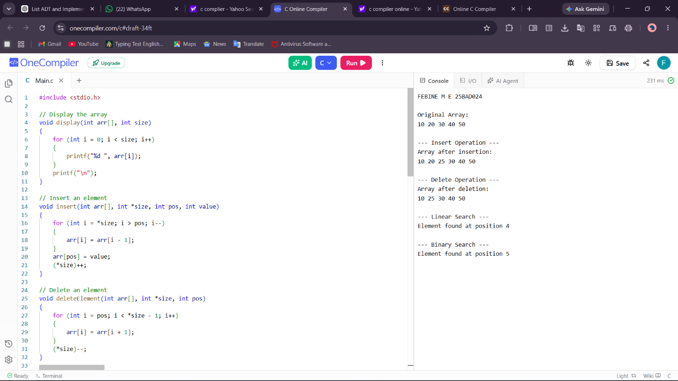

GITHUB LINK : https://github.com/FEBINEME/DSA---24CSI024-FEBINE-M-E-.git

